## Standard Operating Procedure - Auto Patching

NESD-QA [TEST]

*The details supplied in this document will determine the accuracy of the automated workflow procedure. If unsure, please ask for assistance by contacting dca.support@vodacom.co.za.*

Contents

Standard Operating Procedure - Auto Patching 0

**1** **Document Control** 2

**CONTRIBUTORS** 2

**REVIEW AND APPROVAL** 2

**DOCUMENT HISTORY** 2

**2** **Document scope and limitations** 3

**3 Application and Server List** 3

**4 Application Details** 4

**5 Current Patch Effort Breakdown** 4

**6 Prerequisites OS Patching for USSD** 4

**7 Notification – Recipient List** 5

**8 USSD Shutdown Procedure** 5

# **Document Control**

**Please provide the compulsory details related to your application marked in yellow.** **The Yellow portions need to be updated with your application details.**

## **CONTRIBUTORS**

|  |  |  |  |
| --- | --- | --- | --- |
| Name | Designation | Company | Date |
| Pheta Moloi | NESD-QA | Vodacom | 29/03/2022 |
| Mpho Maila | NESD-QA | Vodacom | 29/03/2022 |
| Eliah Mulaudzi | NESD-QA | Vodacom | 29/03/2022 |

REVIEW AND APPROVAL

|  |  |  |
| --- | --- | --- |
| Date | Name | Review and Approved – (insert a ü) |
|  |  |  |
|  |  |  |

DOCUMENT HISTORY

| Revision | Date | Comment |
| --- | --- | --- |
| Pheta Moloi | 29/03/2022 | Initial Draft |
|  |  |  |
|  |  |  |
|  |  |  |

# 

# **Document scope and limitations**

**DCA features that can be added to your workflows are as follows**

1. Auto CRQ creation on discovery of patch requirements. 14 days to remediate.
2. Application stop.
3. Application start.
4. Monitoring Application Status.
5. Email notifications for all status updates.

**Inclusive on auto workflows**

1. OS Patching
2. Kernel update

**Exclusive on auto workflows**

1. Java patching.

**3 Application and Server List**

|  |  |  |  |
| --- | --- | --- | --- |
| **Environment** | **Server Name** | **Physical/Virtual/Shared** | **Total Server Count** |
| TEST | 10.102.208.59 NESDQA-DP3 | Physical | 1 |
| TEST | 10.102.208.58 NESDQA-DP2 | Physical | 1 |
| TEST | 10.13.56.77 NESDQA-TP001 | Physical | 1 |

**4 Application Details**

|  |  |
| --- | --- |
| **Detail** | **Description** |
| **Application Version** | 16.0.200.112 |
| **Operating System**  **Os Type**  **Os Version** | Linux  Redhat  Release 7.9 |
| **Application Owner** | Masiza Qutu |
| **Application Support - Technical SPOC Details** | Pheta Moloi, Mpho Maila, Eliah Mulaudzi |
| **Business Unit** | Engineering Technology |

**5 Current Patch Effort Breakdown**

Please fill in the below table, this will assist in determining if there is savings being provided by automated workflows in your environment.

|  |  |  |  |
| --- | --- | --- | --- |
| **Patching Day** | **Estimation of Time Taken** | **Weekly or Monthly Schedule** | **Number of Servers per Schedule** |
| Friday | 60 Minutes | Weekly | 1 |

**6 Prerequisites OS Patching for USSD**

These are the prerequisites that should be met before commencing with patching activity.

|  |  |
| --- | --- |
| **Prerequisites Checklist** | **Description** |
| **Remedy Change Control required** | No, Test Environment |
| **Approvers** | N/A |
| **Approval Required** | No, only **notification** is required. |
| **Recurring Maintenance Slot** | Yes, every Friday between 18:00 to 23:00 |
| **Notification Required** | Yes, See Notification list under Sec 7 |
| **Backups and/or VM Snapshots required** | NO |

**7 Notification – Recipient List**

Please provide the list of recipients to be notified of patching activities such as progress, failures and success. This can be the Application Manager, the technical resource who is normally involved with patching activity or the team distribution list.

1. [pheta.moloi@vodacom.co.za](mailto:pheta.moloi@vodacom.co.za)
2. [mpho.maila@vcontractor.co.za](mailto:mpho.maila@vcontractor.co.za)
3. [eliah.mulaudzi@vcontractor.co.za](mailto:eliah.mulaudzi@vcontractor.co.za)

**8 ALM Octane Applications Shutdown Procedure**

Steps to shut down the ALM Octane Application instance are outlined below. It is not required to stop the Application when applying security patches as that does not have any negative impact on the service behaviour. Application shutdown is required when there are new Kernel updates to be affected followed by a VM reboot.

**ALM Octane APPLICATION SHUTDOWN**

* 1. Connect to the following servers

|  |  |
| --- | --- |
| **Server Hostname** | **Server IP Address** |
| NESDQA-DP3 | 10.102.208.59 |

1.1 Stop the ALM Octane Application by running the following command through CMD (can take up to 2 minutes to stop).

* *systemctl stop octane*
  1. Confirm that the ALM Octane Application instance is not running, execute the following command.
* *systemctl status octane*

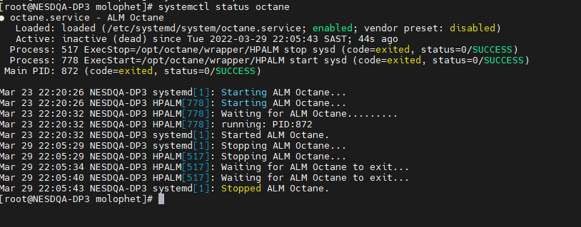

Screenshot showing the results of application stopped successfully

**AUTO PATCHING ACTIVITY TO COMMENCE - Handed over to DCA or AIX Team**

**9 Auto Patching**

These servers do not require any of the application stop/start procedures. Servers can be patched, and reboot is only required to effect new Kernel updates.

|  |  |
| --- | --- |
| **Server Hostname** | **Server IP Address** |
| NESDQA-DP2 | 10.102.208.58 |
| NESDQA-TP001 | 10.13.56.77 |

**10 ALM Octane Application Start-Up Procedure**

ALM Octane server reboot is only required to effect new Kernel updates.

**ALM Octane Application Startup**

1. Connect to the following server

|  |  |
| --- | --- |
| **Server Hostname** | **Server IP Adress** |
| NESDQA-DP3 | 10.102.208.59 |

1. Start the ALM Octane application service on the above server by running the following command through CMD:

* systemctl start octane

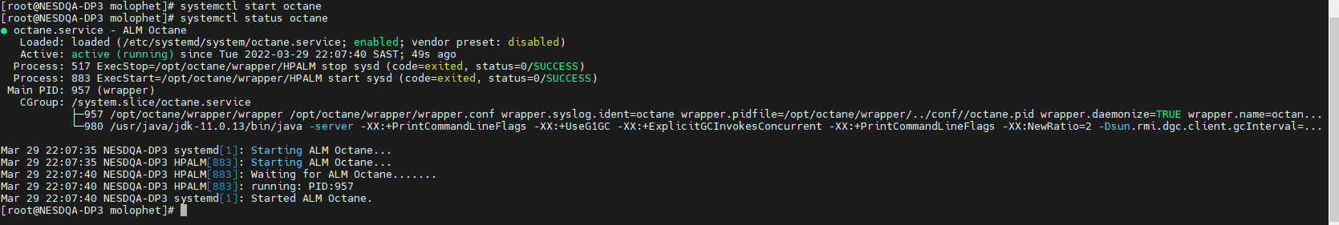

Screenshot showing the results of application started successfully

1. Confirm that the Gain Application Server is up by running the following command on the above-mentioned server.

* Systemctl status octane

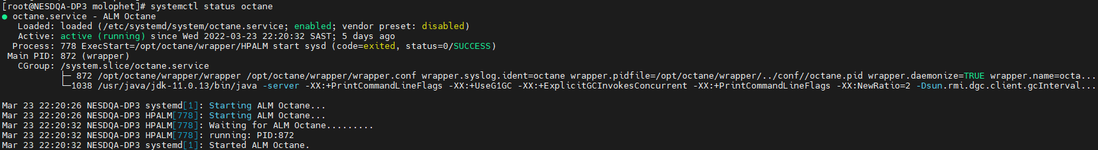

Screenshot showing the results of application running successfully

**END**

Once the document is complete, please log a call to [dca.support@vodacom.co.za](mailto:dca.support@vodacom.co.za) for the team to automate your workflow.